Add Splash Screen on Rect Native

Step 1

install dependency

>>> npm i react-native-splash-screen



* Open vs code

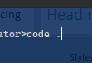

* Rebuild the app

>>> npm start

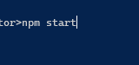

Press **a** for android

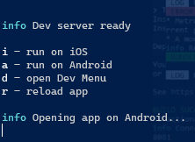

Step 2

**Second step(Plugin Installation)**

* Run this command in your terminal

>>> npx react-native link react-native-splash-screen



Step 3

### Third step(Plugin Configuration)

### Update the MainActivity.java

open MainActivity.java on vs code

android\app\src\main\java\com\smartcalculator

* Add these 2 lines as per instructions

import android.os.Bundle; // here

import org.devio.rn.splashscreen.SplashScreen; // here

